**Chapter 1**

**Integration**

**1.4. Integration Formulas and the Net Change Theorem**

**Section Exercises**

**Use basic integration formulas to compute the following antiderivatives.**

207. 

Answer: 

209. 

Answer: 

211. 

Answer: 

213. Write an integral that expresses the increase in the perimeter  of a square when its side length *s* increases from 2 units to 4 units and evaluate the integral.

Answer: , so  and .

215. A regular *N*-gon (an *N*-sided polygon with sides that have equal length *s*, such as a pentagon or hexagon) has perimeter *Ns*. Write an integral that expresses the increase in perimeter of a regular *N*-gon when the length of each side increases from 1 unit to 2 units and evaluate the integral.

Answer: 

217. A dodecahedron is a Platonic solid with a surface that consists of 12 pentagons, each of equal area. By how much does the surface area of a dodecahedron increase as the side length of each pentagon doubles from 1 unit to 2 units?

Answer: With *p* as in the previous exercise, each of the 12 pentagons increases in area from 2*p* to 4*p* units so the net increase in the area of the dodecahedron is 36*p* units.

219. Write an integral that quantifies the change in the area of the surface of a cube when its side length doubles from *s* unit to 2*s* units and evaluate the integral.

Answer: 

221. Write an integral that quantifies the increase in the surface area of a sphere as its radius doubles from *R* unit to 2*R* units and evaluate the integral.

Answer: 

223. Suppose that a particle moves along a straight line with velocity , where  (in meters per second). Find the displacement at time *t* and the total distance traveled up to .

Answer: . The total distance is 

225. Suppose that a particle moves along a straight line with velocity defined by , where  (in meters per second). Find the displacement at time *t* and the total distance traveled up to .

Answer: . For , . For ,  The total distance is 

227. A ball is thrown upward from a height of 1.5 m at an initial speed of 40 m/sec. Acceleration resulting from gravity is –9.8 m/sec2. Neglecting air resistance, solve for the velocity  and the height  of the ball *t* seconds after it is thrown and before it returns to the ground.

Answer: ; m/s

229. The area  of a circular shape is growing at a constant rate. If the area increases from 4*π* units to 9*π* units between times  and , find the net change in the radius during that time.

Answer: The net increase is 1 unit.

231. Water flows into a conical tank with cross-sectional area *πx*2 at height *x* and volume  up to height *x*. If water flows into the tank at a rate of 1 m3/min, find the height of water in the tank after 5 min. Find the change in height between 5 min and 10 min.

Answer: At , the height of water is . The net change in height from  to  is m.

233. The following table lists the electrical power in gigawatts—the rate at which energy is consumed—used in a certain city for different hours of the day, in a typical 24-hour period, with hour 1 corresponding to midnight to 1 a.m.

|  |  |  |  |
| --- | --- | --- | --- |
| **Hour** | **Power** | **Hour** | **Power** |
| 1 | 28 | 13 | 48 |
| 2 | 25 | 14 | 49 |
| 3 | 24 | 15 | 49 |
| 4 | 23 | 16 | 50 |
| 5 | 24 | 17 | 50 |
| 6 | 27 | 18 | 50 |
| 7 | 29 | 19 | 46 |
| 8 | 32 | 20 | 43 |
| 9 | 34 | 21 | 42 |
| 10 | 39 | 22 | 40 |
| 11 | 42 | 23 | 37 |
| 12 | 46 | 24 | 34 |

Find the total amount of power in gigawatt-hours (gW-h) consumed by the city in a typical 24-hour period.

Answer: The total daily power consumption is estimated as the sum of the hourly power rates, or 911 gW-h.

235. The data in the following table are used to estimate the average power output produced by Peter Sagan for each of the last 18 sec of Stage 1 of the 2012 Tour de France.

Average Power Output

|  |  |  |  |
| --- | --- | --- | --- |
| **Second** | **Watts** | **Second** | **Watts** |
| 1 | 600 | 10 | 1200 |
| 2 | 500 | 11 | 1170 |
| 3 | 575 | 12 | 1125 |
| 4 | 1050 | 13 | 1100 |
| 5 | 925 | 14 | 1075 |
| 6 | 950 | 15 | 1000 |
| 7 | 1050 | 16 | 950 |
| 8 | 950 | 17 | 900 |
| 9 | 1100 | 18 | 780 |

Estimate the net energy used in kilojoules (kJ), noting that 1W = 1 J/s, and the average power output by Sagan during this time interval.

Answer: 17 kJ

237. The distribution of incomes as of 2012 in the United States in $5000 increments is given in the following table. The *k*th row denotes the percentage of households with incomes between  and . The row  contains all households with income between $200,000 and $250,000 and  accounts for all households with income exceeding $250,000.

Income Distributions

|  |  |  |  |
| --- | --- | --- | --- |
| 0 | 3.5 | 21 | 1.5 |
| 1 | 4.1 | 22 | 1.4 |
| 2 | 5.9 | 23 | 1.3 |
| 3 | 5.7 | 24 | 1.3 |
| 4 | 5.9 | 25 | 1.1 |
| 5 | 5.4 | 26 | 1.0 |
| 6 | 5.5 | 27 | 0.75 |
| 7 | 5.1 | 28 | 0.8 |
| 8 | 4.8 | 29 | 1.0 |
| 9 | 4.1 | 30 | 0.6 |
| 10 | 4.3 | 31 | 0.6 |
| 11 | 3.5 | 32 | 0.5 |
| 12 | 3.7 | 33 | 0.5 |
| 13 | 3.2 | 34 | 0.4 |
| 14 | 3.0 | 35 | 0.3 |
| 15 | 2.8 | 36 | 0.3 |
| 16 | 2.5 | 37 | 0.3 |
| 17 | 2.2 | 38 | 0.2 |
| 18 | 2.2 | 39 | 1.8 |
| 19 | 1.8 | 40 | 2.3 |
| 20 | 2.1 | 41 |  |

* 1. Estimate the percentage of U.S. households in 2012 with incomes less than $55,000.
  2. What percentage of households had incomes exceeding $85,000?
  3. Plot the data and try to fit its shape to that of a graph of the form  for suitable .

Answer: a. 54.3%; b. 27.00%; c. The curve in the following plot is .

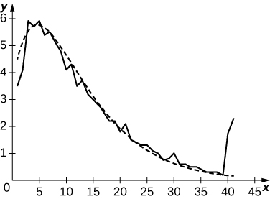

239. For a given motor vehicle, the maximum achievable deceleration from braking is approximately 7 m/sec2 on dry concrete. On wet asphalt, it is approximately 2.5 m/sec2. Given that 1 mph corresponds to 0.447 m/sec, find the total distance that a car travels in meters on dry concrete after the brakes are applied until it comes to a complete stop if the initial velocity is 67 mph (30 m/sec) or if the initial braking velocity is 56 mph (25 m/sec). Find the corresponding distances if the surface is slippery wet asphalt.

Answer: In dry conditions, with initial velocity  m/s,  and, if , . In wet conditions, if , and  and if , .

241. Sandra is a 25-year old woman who weighs 120 lb. She burns  cal/hr while walking on her treadmill. Her caloric intake from drinking Gatorade is 100*t* calories during the *t*th hour. What is her net decrease in calories after walking for 3 hours?

Answer: 225 cal

243. Although some engines are more efficient at given a horsepower than others, on average, fuel efficiency decreases with horsepower at a rate of  mpg/horsepower. If a typical 50-horsepower engine has an average fuel efficiency of 32 mpg, what is the average fuel efficiency of an engine with the following horsepower: 150, 300, 450?

Answer: , , 

245. **[T]** The following table provides hypothetical data regarding the level of service for a certain highway.

|  |  |  |
| --- | --- | --- |
| **Highway Speed Range (mph)** | **Vehicles per Hour per Lane** | **Density Range (vehicles/mi)** |
| > 60 | < 600 | < 10 |
| 60–57 | 600–1000 | 10–20 |
| 57–54 | 1000–1500 | 20–30 |
| 54–46 | 1500–1900 | 30–45 |
| 46–30 | 1900**–**2100 | 45–70 |
| <30 | Unstable | 70–200 |

* 1. Plot vehicles per hour per lane on the *x*-axis and highway speed on the *y*-axis.
  2. Compute the average decrease in speed (in miles per hour) per unit increase in congestion (vehicles per hour per lane) as the latter increases from 600 to 1000, from 1000 to 1500, and from 1500 to 2100. Does the decrease in miles per hour depend linearly on the increase in vehicles per hour per lane?
  3. Plot minutes per mile (60 times the reciprocal of miles per hour) as a function of vehicles per hour per lane. Is this function linear?

Answer: a.

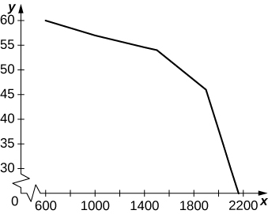

b. Between 600 and 1000 the average decrease in vehicles per hour per lane is –0.0075. Between 1000 and 1500 it is –0.006 per vehicles per hour per lane, and between 1500 and 2100 it is –0.04 vehicles per hour per lane. c.

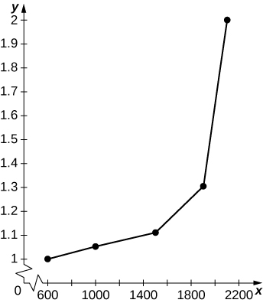

The graph is nonlinear, with minutes per mile increasing dramatically as vehicles per hour per lane reach 2000.

**For the next two exercises use the data in the following table, which displays bald eagle populations from 1963 to 2000 in the continental United States.**

|  |  |
| --- | --- |
| **Year** | **Population of Breeding Pairs of Bald Eagles** |
| 1963 | 487 |
| 1974 | 791 |
| 1981 | 1188 |
| 1986 | 1875 |
| 1992 | 3749 |
| 1996 | 5094 |
| 2000 | 6471 |

247. **[T]** The graph below plots the cubic  against the data in the preceding table, normalized so that  corresponds to 1963. Estimate the average number of bald eagles per year present for the 37 years by computing the average value of *p* over .

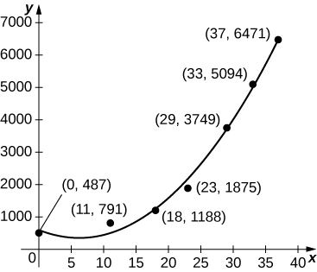

Answer: 

**As a car accelerates, it does not accelerate at a constant rate; rather, the acceleration is variable. For the following exercises, use the following table, which contains the acceleration measured at every second as a driver merges onto a freeway.**

|  |  |
| --- | --- |
| **Time (sec)** | **Acceleration (mph/sec)** |
| 1 | 11.2 |
| 2 | 10.6 |
| 3 | 8.1 |
| 4 | 5.4 |
| 5 | 0 |

249. **[T]** The accompanying graph plots the best quadratic fit, , to the data from the preceding table. Compute the average value of  to estimate the average acceleration between  and .

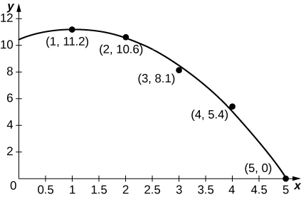

Answer: Average acceleration is mph/s

251. **[T]** Using your velocity equation from the previous exercise, find the corresponding distance equation, assuming your initial distance is 0 mi. How far did you travel while you accelerated your car? (*Hint:* You will need to convert time units.)

Answer: . Then, mphfeet.

253. **[T]** An athlete runs by a motion detector, which records her speed, as displayed in the following table. The best linear fit to this data, is shown in the accompanying graph. Use the average value of  between  and  to estimate the runner’s average speed.

|  |  |
| --- | --- |
| **Minutes** | **Speed (m/sec)** |
| 0 | 5 |
| 10 | 4.8 |
| 20 | 3.6 |
| 30 | 3.0 |
| 40 | 2.5 |

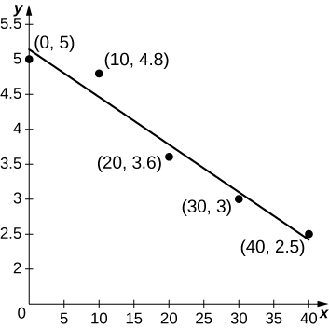

Answer: 

This file is copyright 2016, Rice University. All Rights Reserved.